Description:

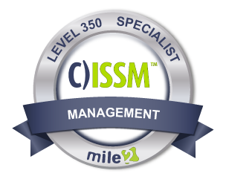

Companies will lean on a Certified IS Security Manager, C)ISSM to create solutions for tomorrow's problems, today. When it comes to identifying critical issues and providing effective IS management solutions. The knowledge and

course content provided in the Certified Information Systems Security Manager - C)ISSM will not only cover ISACA®'s CISM exam but will provide a measurable certification that demonstrates proficiency in the IS Management Field. The Certified Information Systems Security Manager covers the skills and knowledge to assess threat analysis and risks, Risk & incident management, Security programs and CISO roles, IS security strategy and frameworks, Audit and Risk management creation of policies, compliance and awareness, as well as DR and BCP development, deployment and maintenance.

Annual Salary Potential $83,169 AVG/year

Key Course Information

Live Class Duration: 4 Days
CEUs: 32
Language: English
Class Formats Available:
Instructor Led
Self-Study
Live Virtual Training
Suggested Prerequisites:

- Mile2’s C)SP
- 12 months of Information Systems Experience

Who Should Attend

Module 1 -Information Security Governance
Module 2 -Information Risk Management
Module 3 -Information Security Program Development and Management
Module 4 -Information Security Incident Management

Key Course Information
Modules/Lessons

- Penetration Testers
- Microsoft Administrators
- Security Administrators
- Active Directory Admins

Accreditations
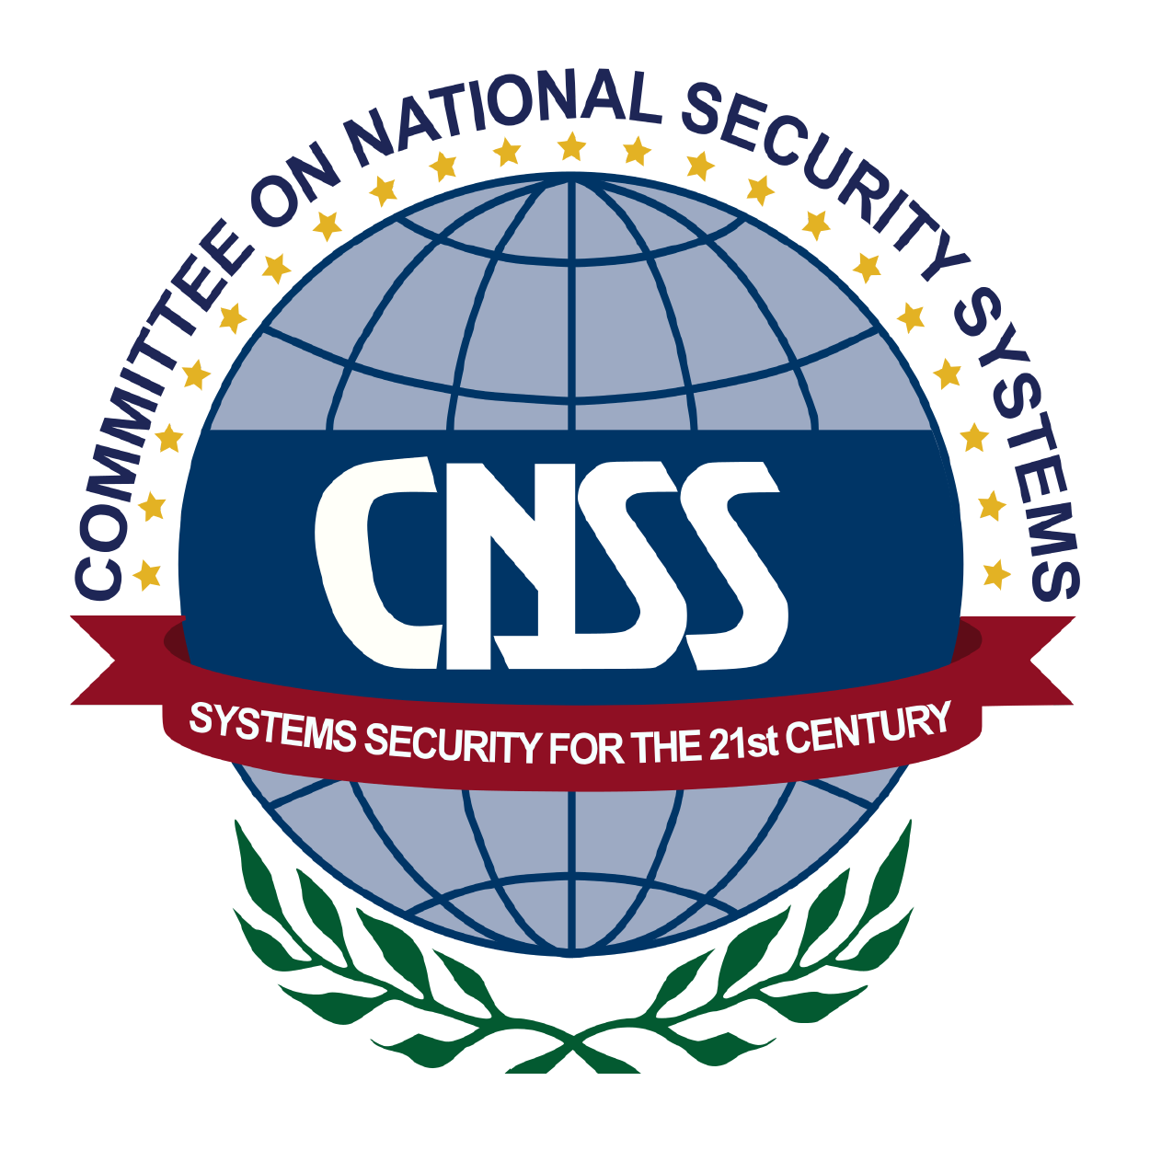

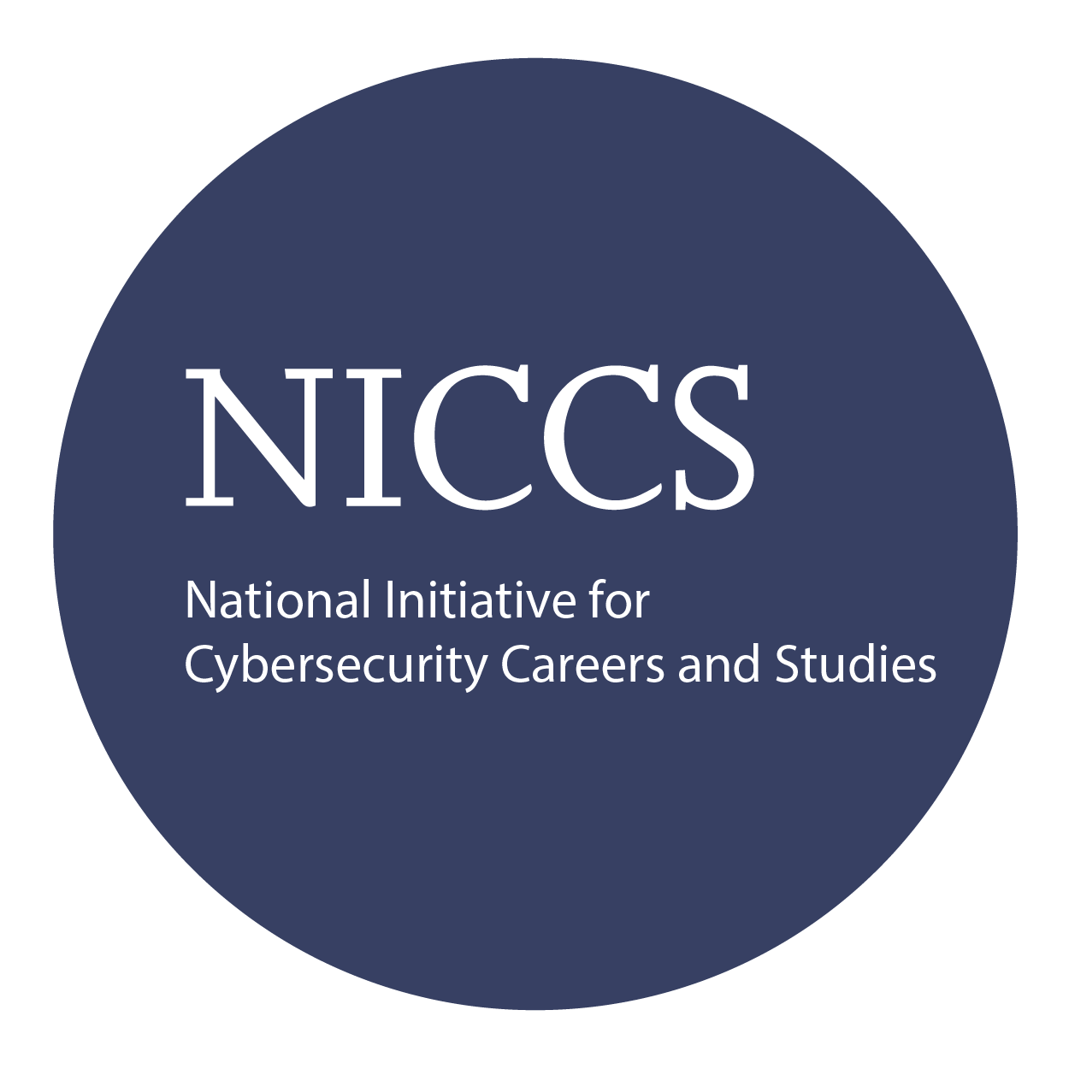
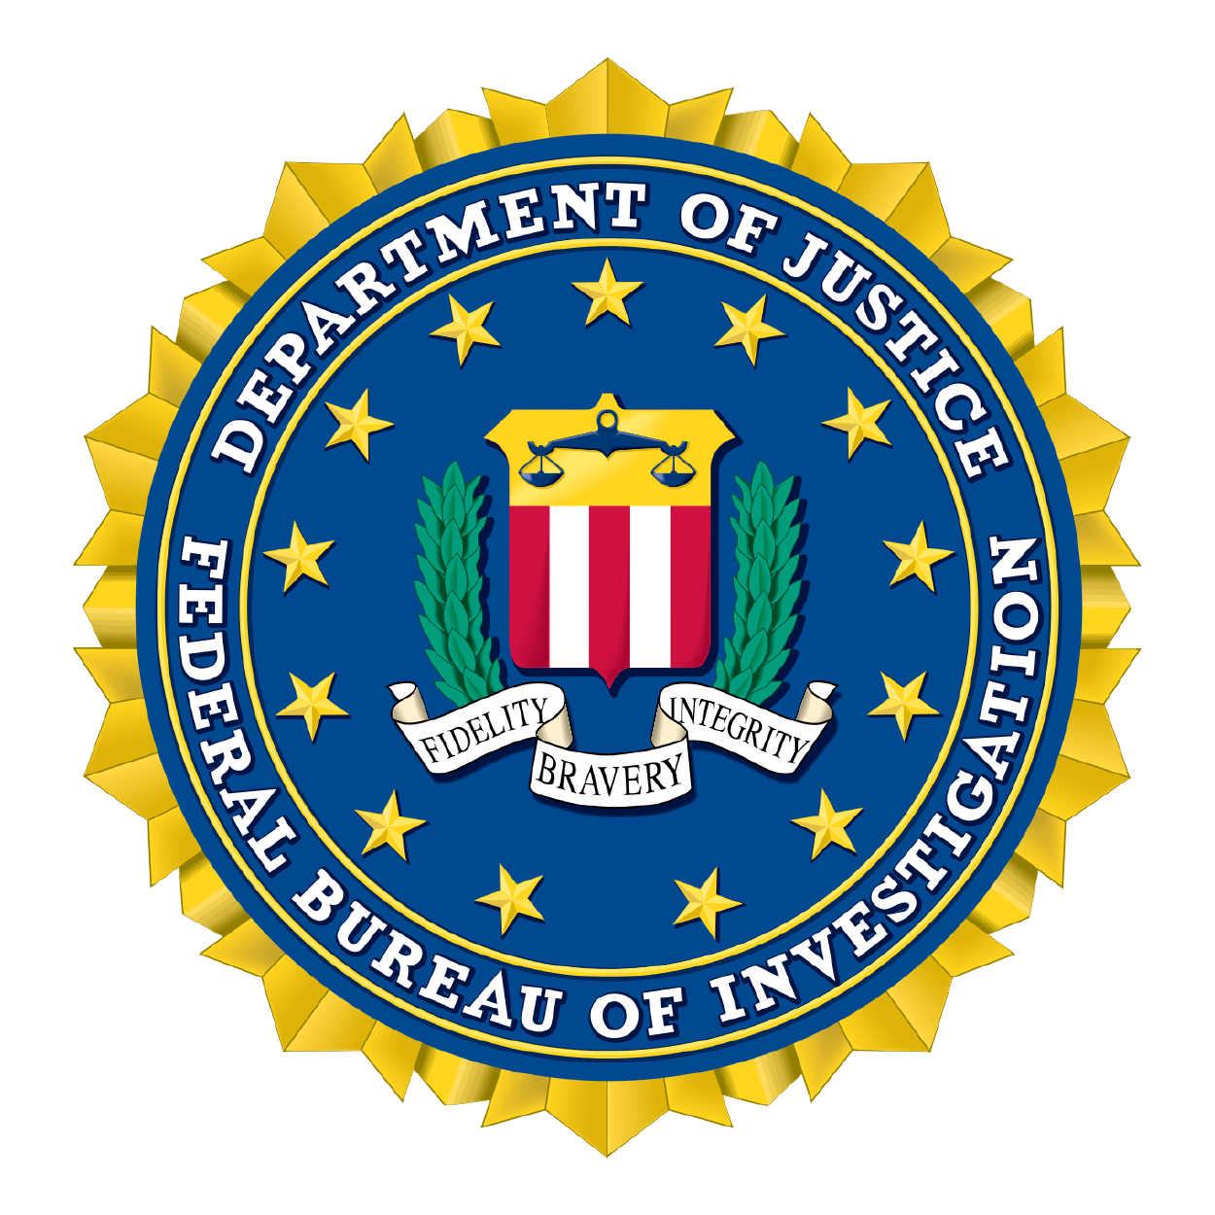

Exam Information
Upon Completion

The Certified Information Systems Security Manager exam is taken online through Mile2’s Learning Management System and is accessible on you Mile2.com account. The exam will take approximately 2 hours and consist of 100 multiple choice questions.
A minimum grade of 70% is required for certification.

All Mile2 certifications will be awarded a 3-year expiration date.

There are two requirements to maintain Mile2 certification:

- Pass the most current version of the exam for your respective existing certification
- Earn and submit 20 CEUs per year in your Mile2 account.

Upon completion, Certified IS Security Manager students will have a strong foundation in Cyber Security & IS management standards with current best practices and will be prepared to competently take the C)ISSM exam.

Question: Do I have to purchase a course to buy a certification exam?
Answer: No
Question: Do all Mile2 courses map to a role-based career path?
Answer: Yes. You can find the career path and other courses associated with it at www.mile2.com.
Question: Are all courses available as self-study courses?
Answer: Yes. There is however 1 exception. The Red Team vs Blue Team course is only available as a live class.
Question: Are Mile2 courses transferable/shareable?
Answer: No. The course materials, videos, and exams are not meant to be shared or transferred.
Course FAQ’s

Re-Certification Requirements

Course and Certification Learning Options
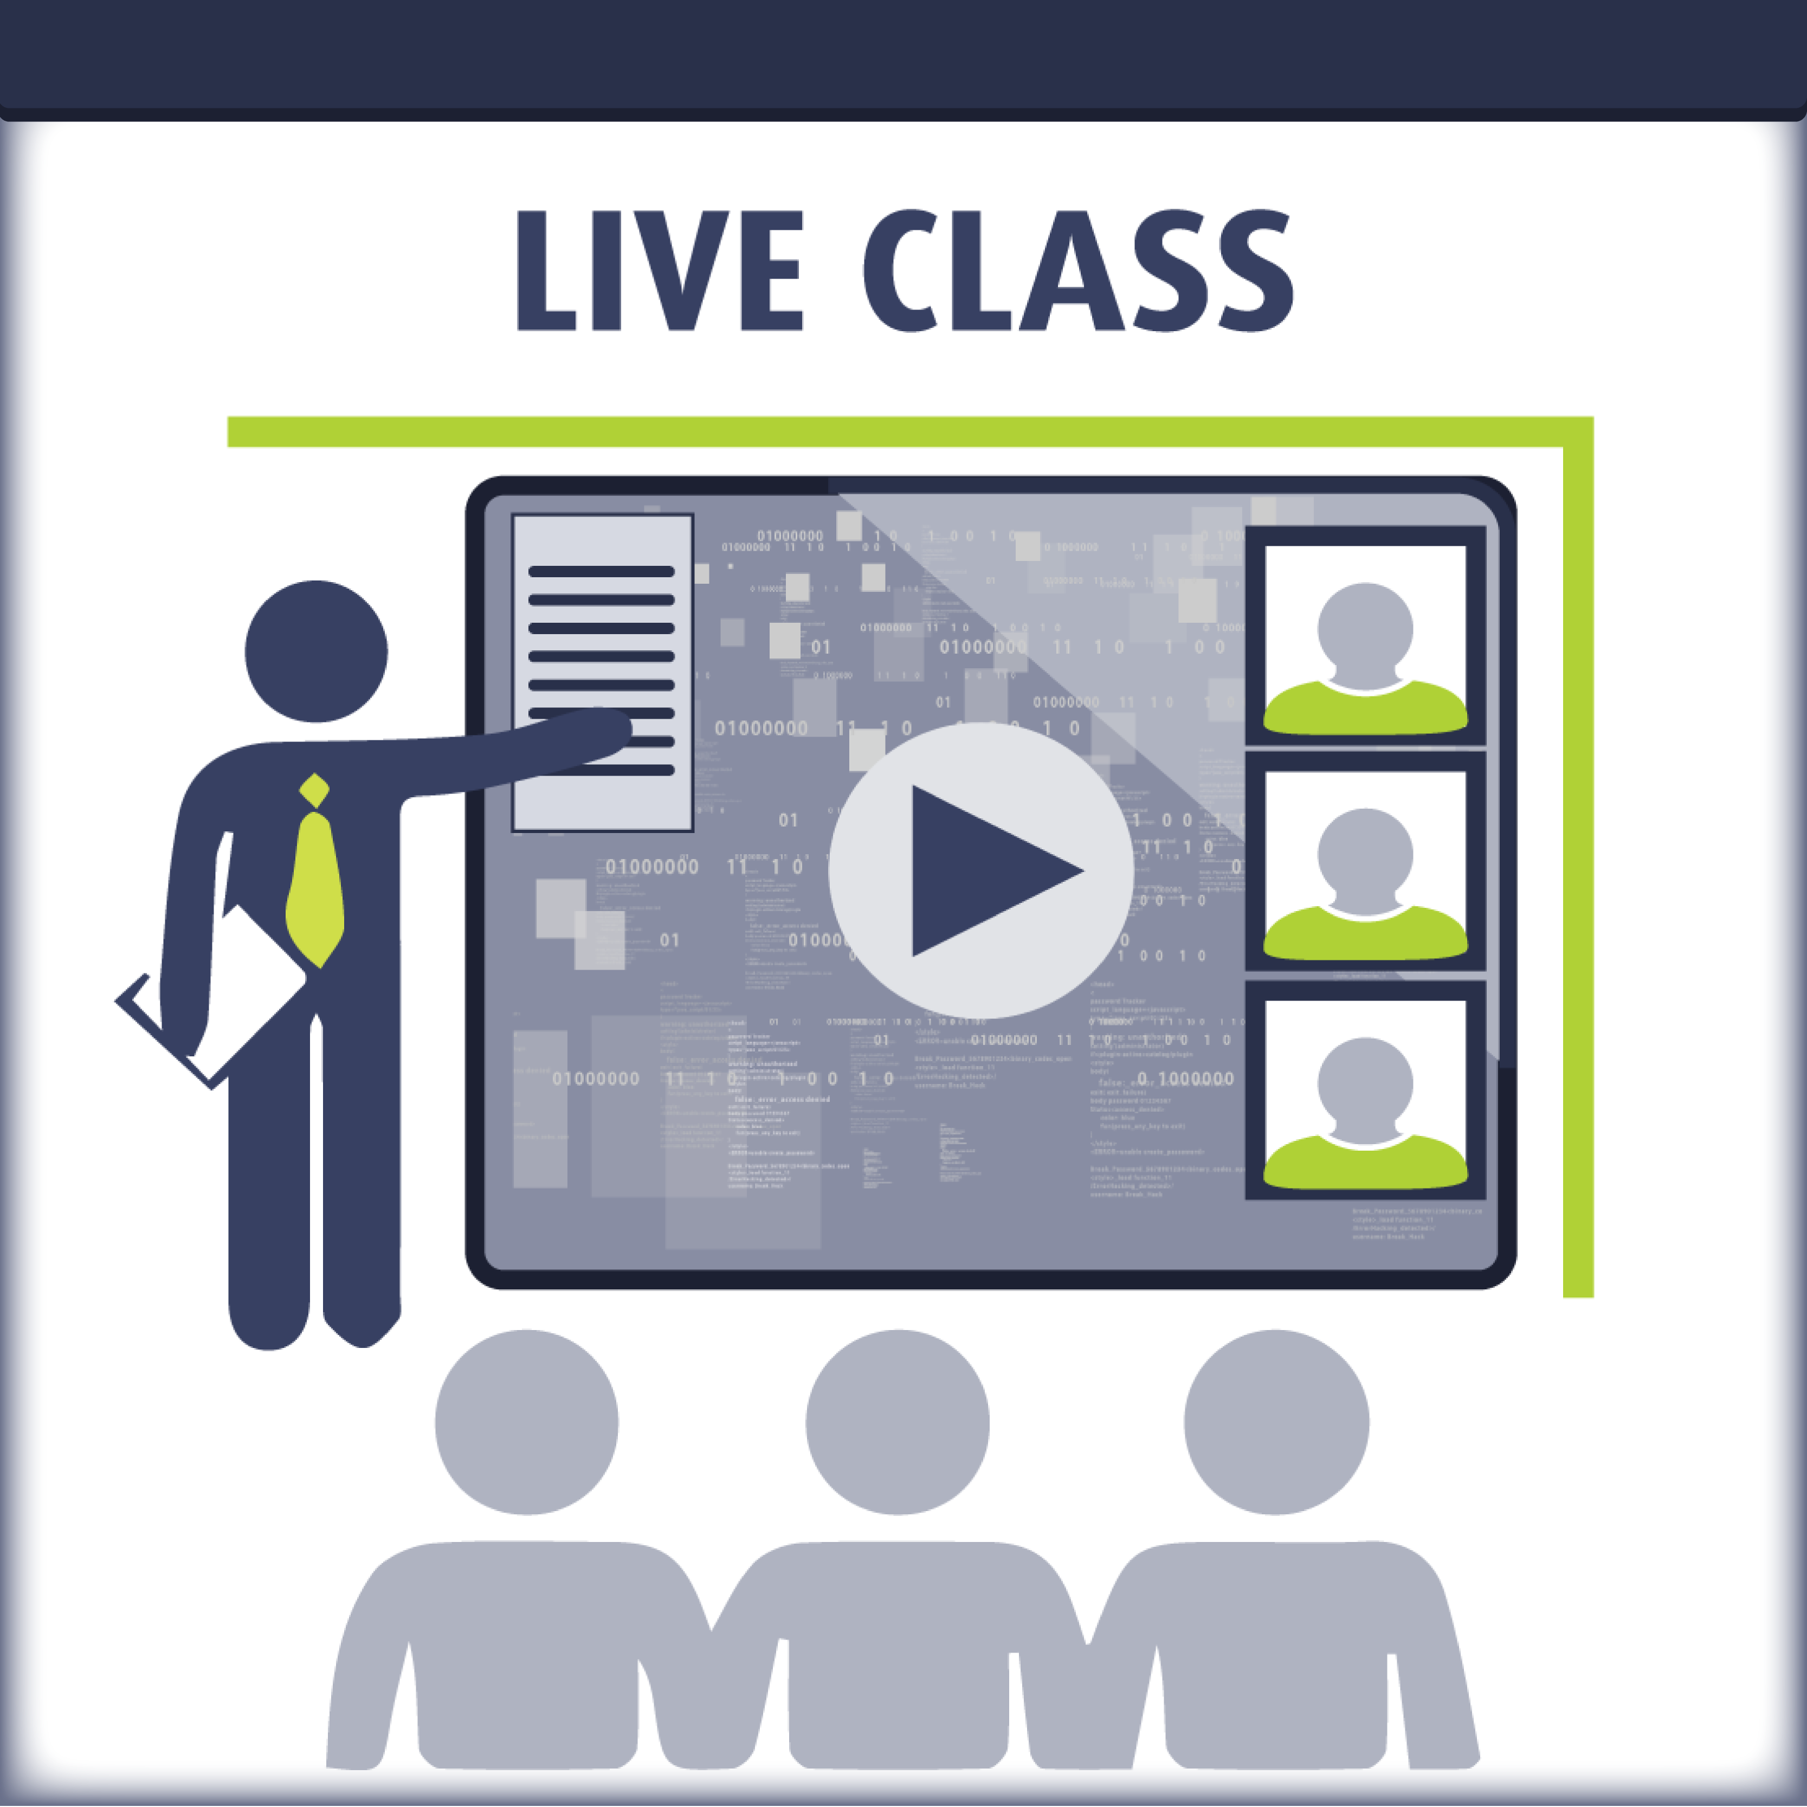
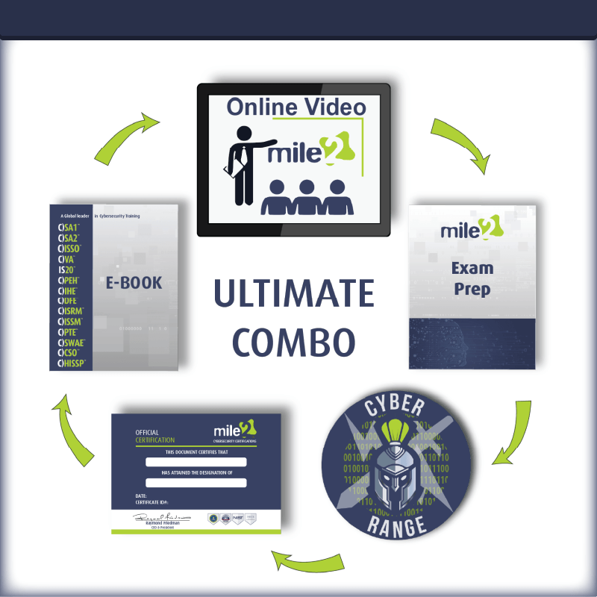
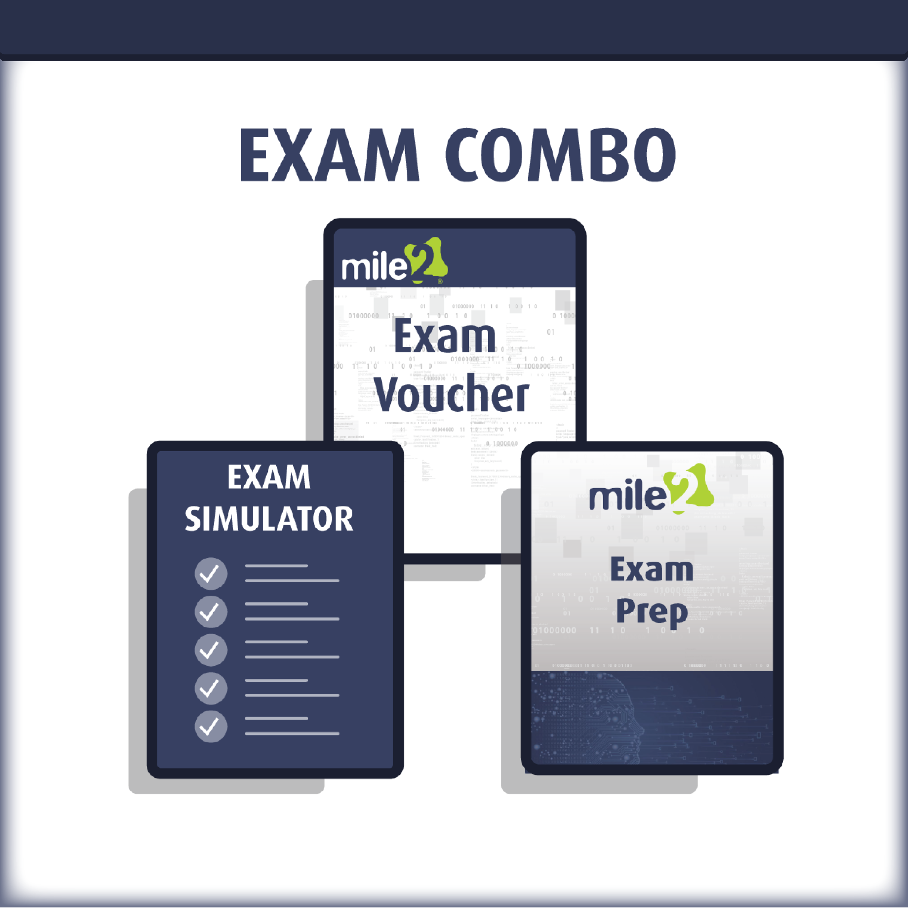

Detailed Outline:
Course Introduction

- Module 1 – Introduction

- Agenda
- Daily Format
- Domain Structure
- Course Structure and Logistics

- Module 2 – Architectural Concepts and Design Requirements
- IS Governance Overview
- IS Strategy
- IS Programs, Architectures, and Frameworks
- Committees and Responsibilities
- Auditing and Evaluating Information Systems
- Reporting and Compliance
- Ethics

- Module 3 – Information Risk Management
- Roles and Responsibilities
- What is Risk and Risk Management
- Risk Assessment, Treatment
- Risk Mitigation and Controls
- Auditing
- Human Resource Risk
- Training and Awareness

- Module 4 – Information Security Program Development and Management
  - Information Security Strategy and Management
  - Security Program Development
  - Operations Security Technologies
  - Evaluating and Information Security System

- Module 5 – Information Security Incident Management
  - Goals of Incident Management and Response
  - Developing Response and Recovery Plans
  - Plan of Action for Incident Management
  - Challenges in Incident Management
  - Post Event Reviews
  - Notification Requirements
  - Insurance
  - Testing Response and Recovery Plans
  - BCP and DRP Training

