Description:

Secure Web Application Engineers work to design information systems that are secure on the web. Organizations and governments fall victim to internet-based attacks every day. In many cases, web attacks could be thwarted but hackers, organized criminal gangs, and foreign agents are able to exploit

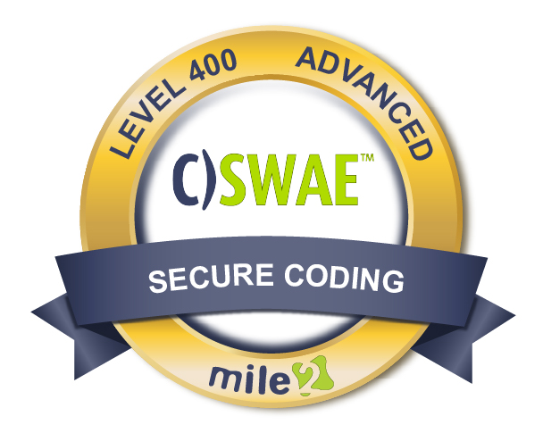

weaknesses in web applications. The Secure Web programmer knows how to identify, mitigate and defend against all attacks through designing and building systems that are resistant to failure. With this course you will learn how to develop web applications that aren't subject to common vulnerabilities, and how to test and validate that their applications are secure, reliable and resistant to attack.

Annual Salary Potential $71,072 AVG/year

**Live Class Duration:** 5 Days

**CEUs:** 40

**Language:** English

**Class Formats Available:**

• Instructor Led

• Self-Study

• Live Virtual Training

**Suggested Prerequisites:**

• Sound knowledge of networking

• At least one coding language

• Linux understanding

• Open shell

Or 24 months experience in software technologies and security.

Hands-On Labs

Modules/Lessons

Key Course Information

**Lab 01**: Environment Setup and Architecture

**Lab 02**: OWASP TOP 10 2013

**Lab 03**: Threat Modeling

**Lab 04**: Application Mapping & Analysis

**Lab 05**: Authentication and Authorization attacks

**Lab 06**: Session Management attacks  
**Lab 09**: AJAX Security

**Lab 10**: Code Review and Security Testing

**Lab** **11**: Alternatives Labs

**Module 01**: Web Application Security

**Module 02**: Secure SDLC

**Module 03**: OWASP Top 10

**Module 04**: Risk Management

**Module 05**: Threat Modeling

**Module 06**: Authentication and Authorization Attacks

**Module 07**: Session Management

**Module 08**: Security Architecture

**Module 09**: Data Validation

**Module 10**: AJAX Security

**Module 11**: Insecurity Code Review and Mitigation

**Module 12:** Application Mapping Analysis

**Module 13**: Cryptography

**Module 14**: Web Application Penetration Testing

Key Course Information

Exam Information

Upon Completion

The Certified Secure Web   
Application Engineer exam is taken online through Mile2’s Learning Management System and is accessible on you Mile2.com account. The exam will take approximately 2 hours and consist of 100 multiple choice questions.

A minimum grade of 70% is required for certification.

All Mile2 certifications will be awarded a 3-year expiration date.

There are two requirements to maintain Mile2 certification:

1. Pass the most current version of the exam for your respective existing certification
2. Earn and submit 20 CEUs per year in your Mile2 account.

Upon completion, Certified Secure Web Application Engineer students will be able to establish industry acceptable auditing standards with current best practices and policies.

Students will also be prepared to competently take the C)SWAE exam.

• Pen Testers

• Security Officers

• Ethical Hackers

• Network Auditors

• Vulnerability assessors

• System Owners and Managers

• Cyber Security Engineers

**Question:** Do I have to purchase a course to buy a certification exam?

Answer: No

**Question:** Do all Mile2 courses map to a role-based career path?

Answer: Yes. You can find the career path and other courses associated with it at [www.mile2.com](http://www.mile2.com).

**Question:** Are all courses available as self-study courses?

Answer: Yes. There is however 1 exception. The Red Team vs Blue Team course is only available as a live class.

**Question:** Are Mile2 courses transferable/shareable?

Answer: No. The course materials, videos, and exams are not meant to be shared or transferred.

Course FAQ’s

Who Should Attend

Re-Certification

Requirements

Accreditations







Course and Certification Learning Options

