Description:
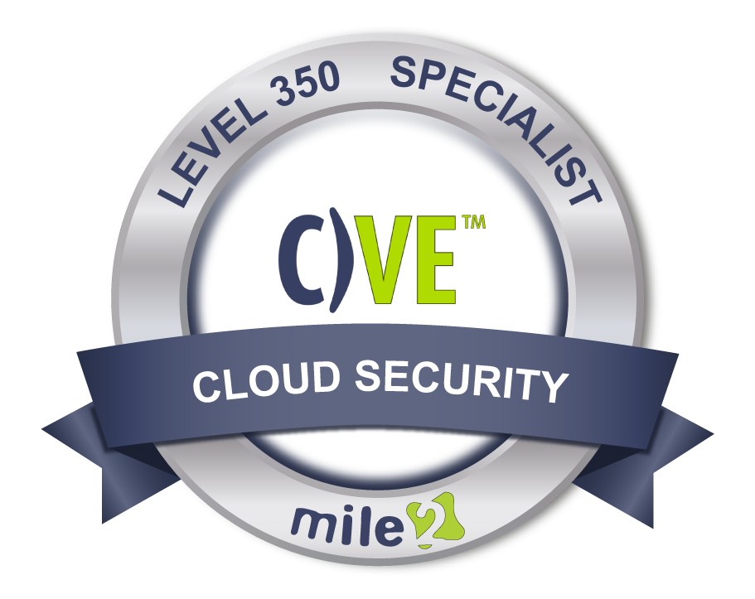
This fast-paced, high energy, hands-on course provides not only the foundation needed for a top performing software-defined data center, it also provides the latest in virtualization and cloud technologies which gives the engineer or administrator the knowledge and skills needed to design and manage the datacenter for tomorrow's needs.

This course will cover everything from design, installation, configuration, best practices, performance monitoring, and just about everything in between!

Annual Salary Potential $76,000 AVG/year

Key Course Information

Live Class Duration: 4 Days
CEUs: 32
Language: English
Class Formats Available:
Instructor Led
Self-Study
Live Virtual Training
Suggested Prerequisites:
• Mile 2 C)HT and C)OST or equivalent knowledge
OR
• 24 months experience with Microsoft or Linux servers

Lab 1 – Installing the Hypervisor
Lab 2 – ESXi Management
Lab 3 – Managing ESXi with vSphere
Lab 4 – SSH Access
Lab 5 – Syslog Settings
Lab 6 – Controlling User Access
Lab 7 – Active Directory Integration
Lab 8 – Managing ESXi Firewall
Lab 9 – Attach ESXi to host via vSphere
Lab 10 – Getting around the vShpere Web Client
Lab 11 – Setting NTP on ESXi Host
Lab 12 – Setup vCenter Appliance
Lab 13 – Create Virtual Switches
Lab 14– 39: See Detailed Outline Below

Hands-On Labs

Module 1 - Software Defined Datacenter
Module 2 - Installing and Managing ESXi
Module 3 - Installing and Managing vCenter
Module 4 - Configuring and Managing a vSwitch
Module 5 - Configuring and Managing Storage
Module 6 - Configuring and Managing Virtual Machines
Module 7 - Configuring and Managing Distributed Switches
Module 8 - vSphere Management
Module 9 - Backup and Disaster Recovery Implementation and Management
Module 10 – 12: See Detailed Outline below

Key Course Information
Modules/Lessons

Exam Information
Upon Completion

The Certified Virtualization Engineer exam is taken online through Mile2’s Learning Management System and is accessible on you Mile2.com account. The exam will take approximately 2 hours and consist of 100 multiple choice questions.
A minimum grade of 70% is required for certification.

All Mile2 certifications will be awarded a 3-year expiration date.

There are two requirements to maintain Mile2 certification:

- Pass the most current version of the exam for your respective existing certification
- Earn and submit 20 CEUs per year in your Mile2 account.

Upon completion, students will have learned the
pros, cons, best practices, and skills of
virtualization. They will be able to design, secure,
deploy, and manage virtual machines and be
prepared to take the C)VE Exam.

- Vitualization and Cloud Administrators and Engineers
- Systems Administrators
- Cloud Security Engineers
- Systems Engineers

Question: Do I have to purchase a course to buy a certification exam?
Answer: No
Question: Do all Mile2 courses map to a role-based career path?
Answer: Yes. You can find the career path and other courses associated with it at www.mile2.com.
Question: Are all courses available as self-study courses?
Answer: Yes. There is however 1 exception. The Red Team vs Blue Team course is only available as a live class.
Question: Are Mile2 courses transferable/shareable?
Answer: No. The course materials, videos, and exams are not meant to be shared or transferred.
Course FAQ’s

Who Should Attend

Re-Certification
Requirements

Accreditations
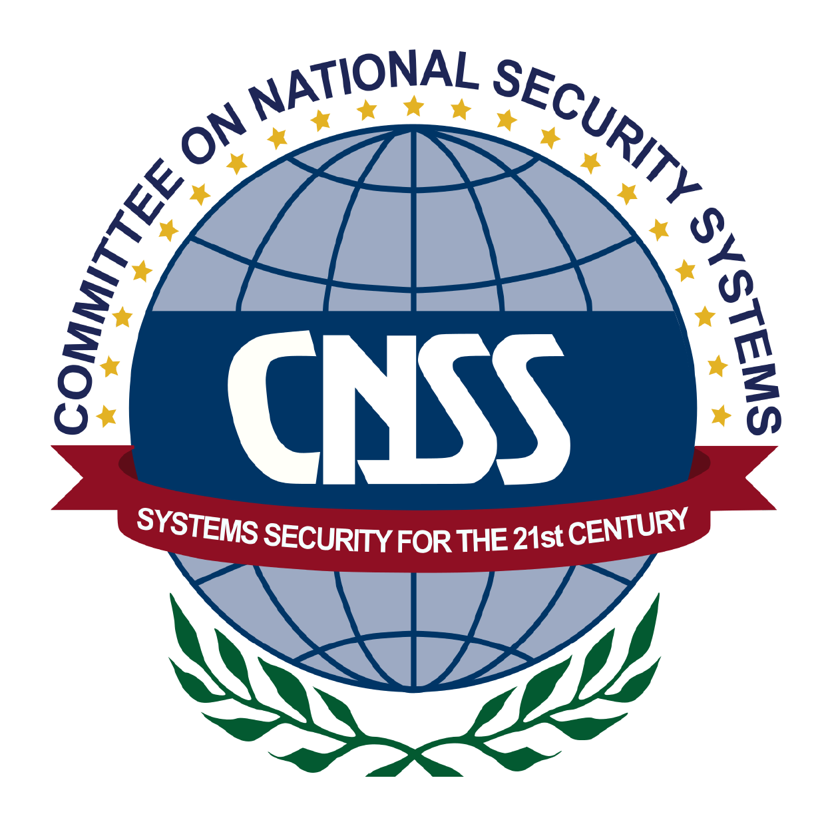

Course and Certification Learning Options
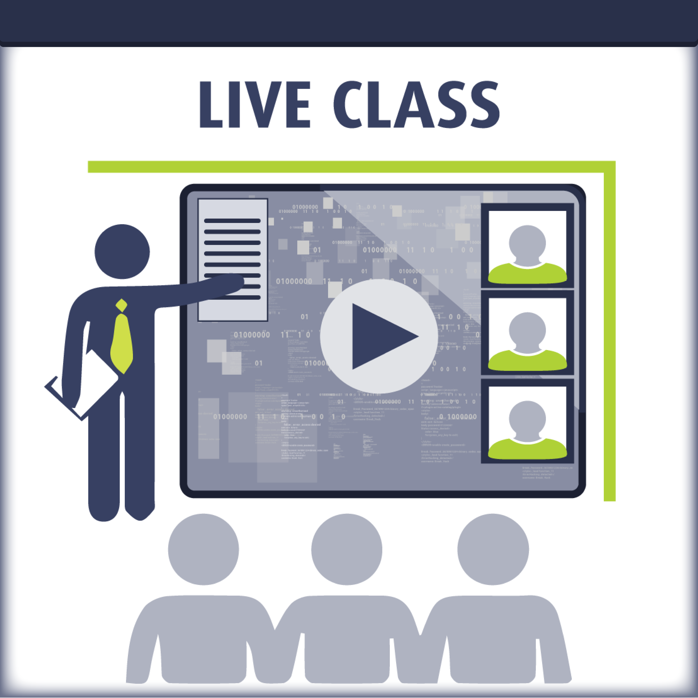
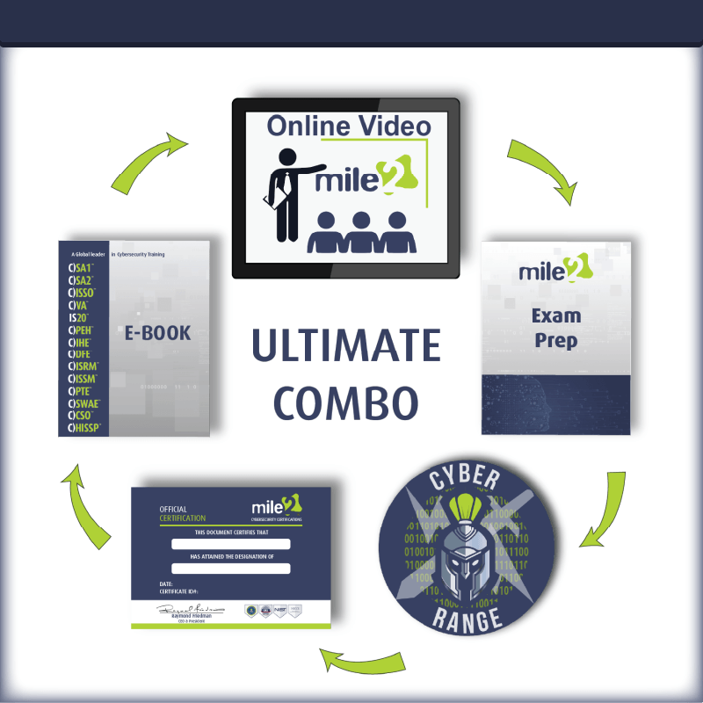
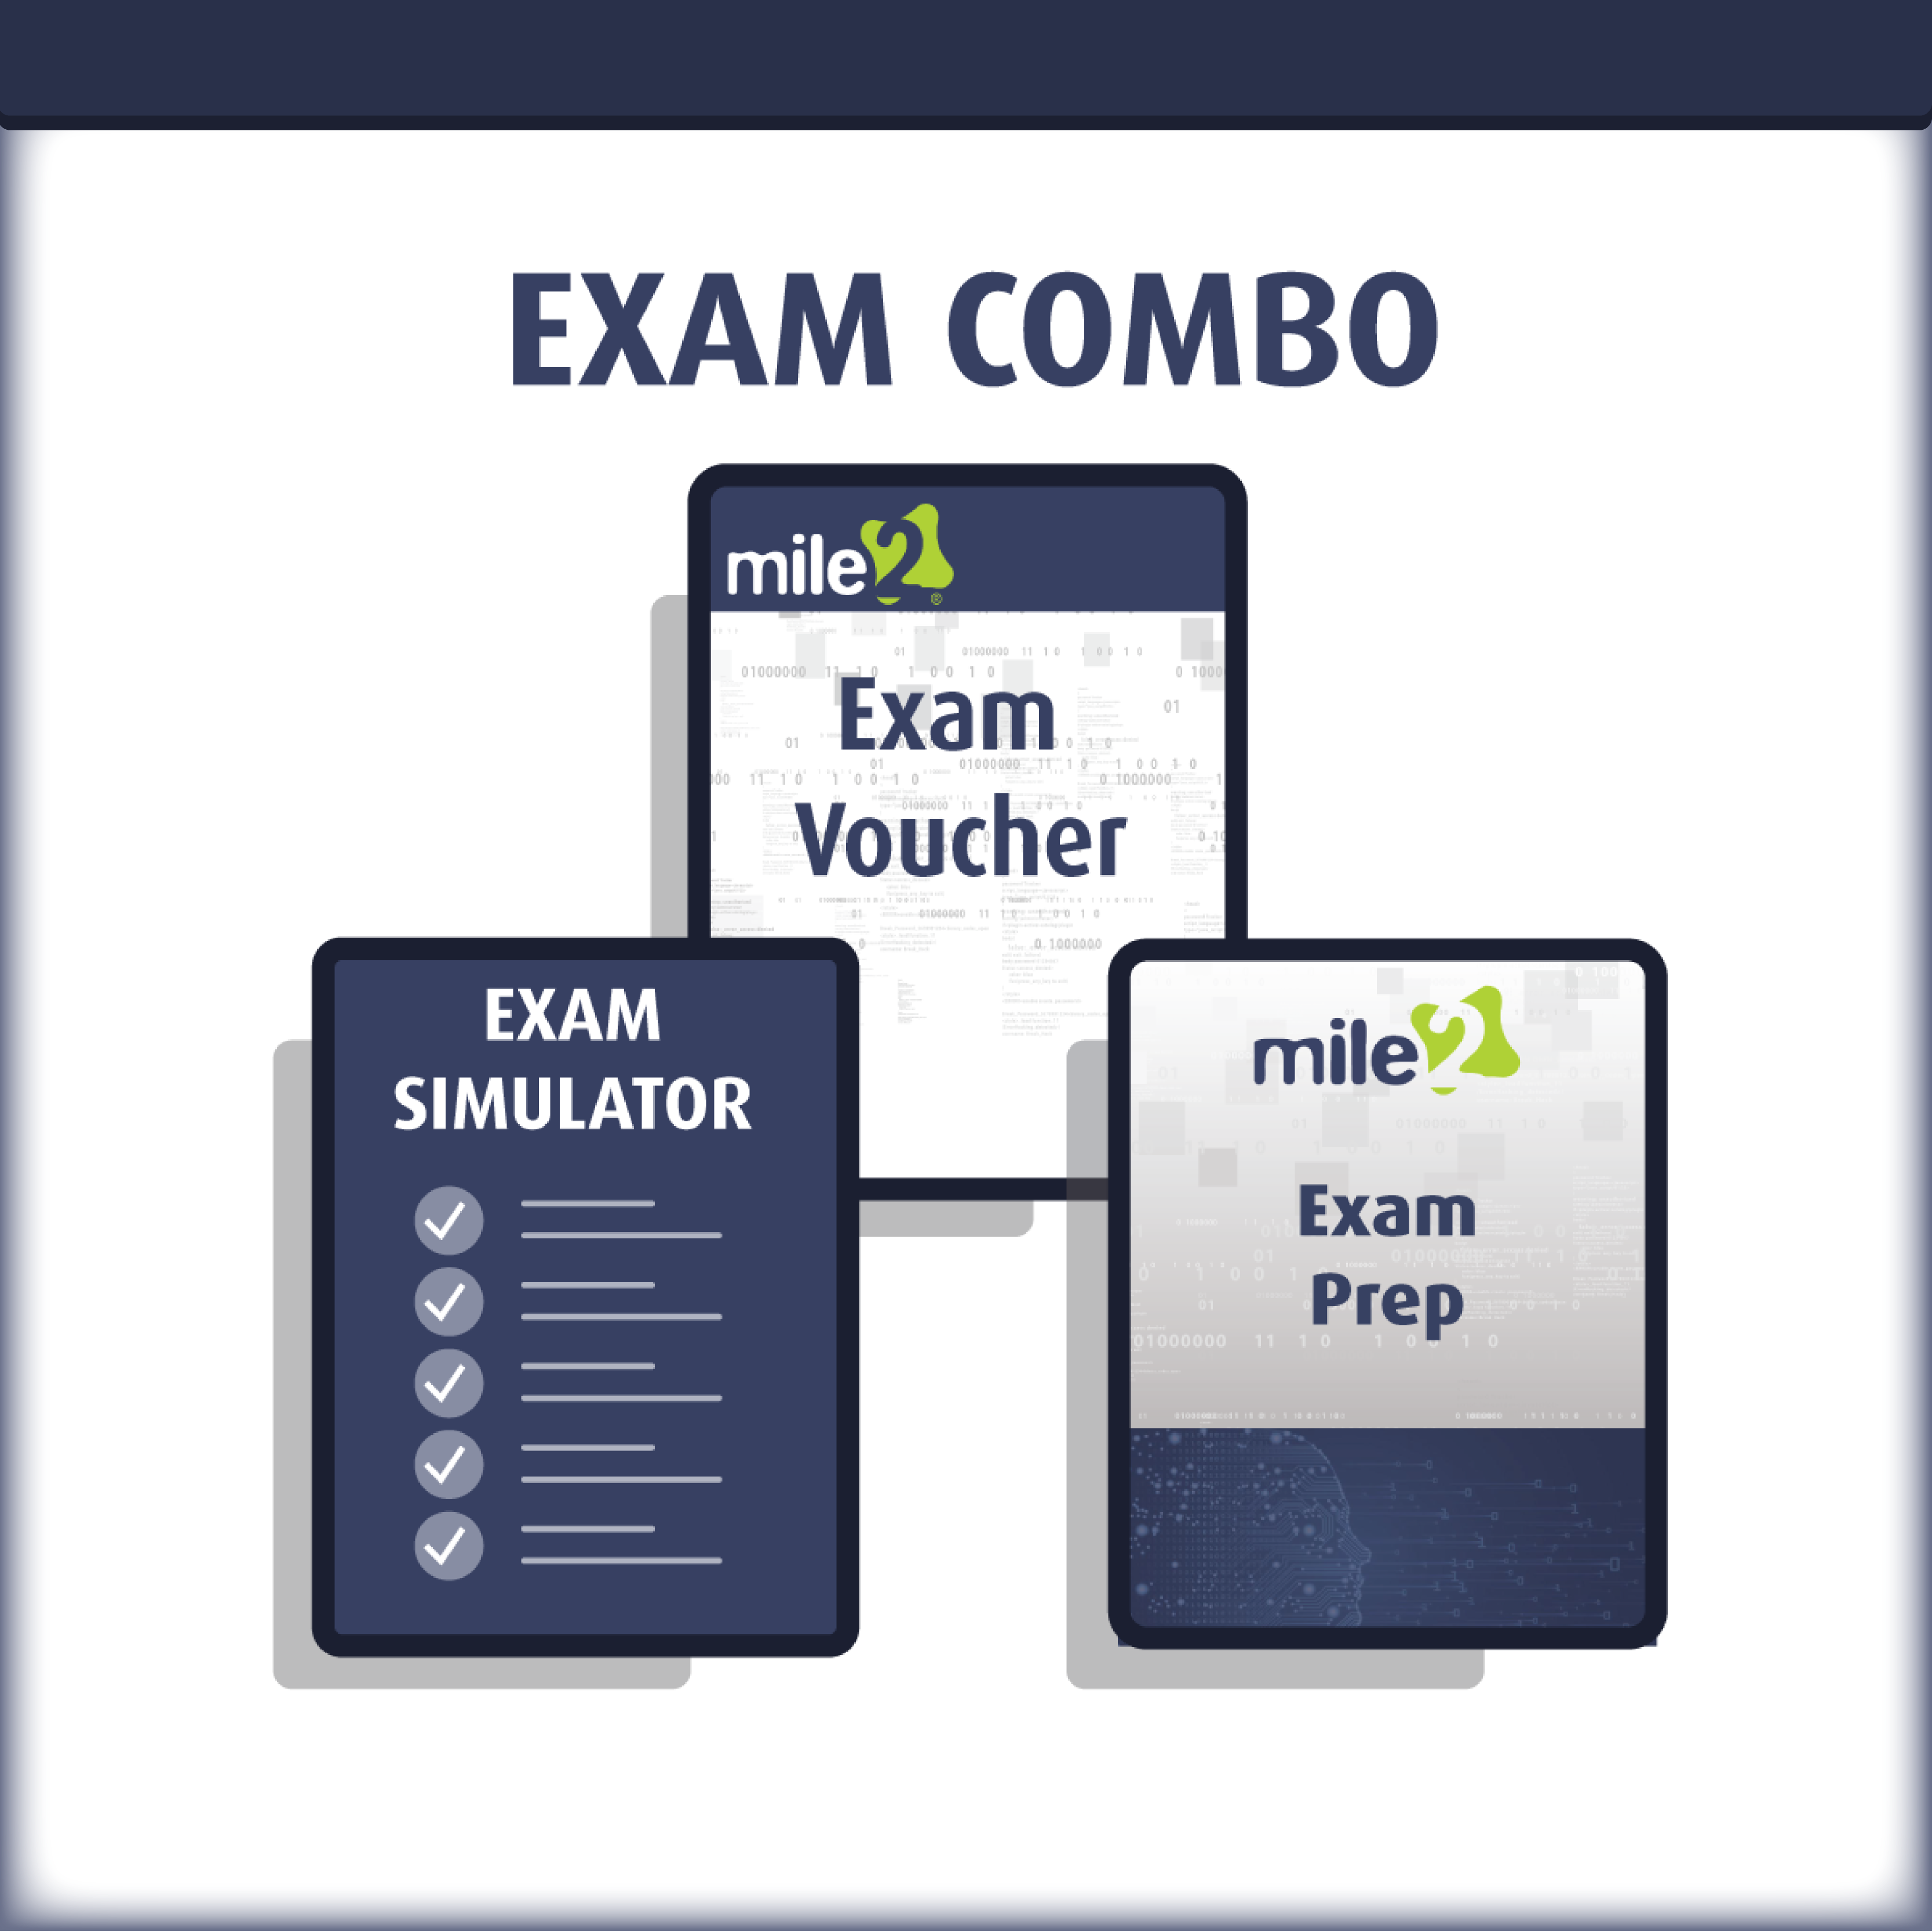

Detailed Outline:
Chapter 1 – Software Defined Datacenter
- Overview of Virtualization
- Overview of Public and Private Cloud
- How it all fits together
  - Designing the Datacenter for today and tomorrow
  - Key technologies for a virtual and private cloud datacenter

Chapter 2 – Installing and Managing ESXi

- Planning for the Installation
  - Installation Options
  - Auto Deploy
- Installing ESXi (Hands On Lab (HOL))
  - Using the DCUI (HOL)
  - ESXi Configuration Settings (HOL)
    - Hostname Resolution (HOL)
    - NTP (HOL)
    - IP Address (HOL)
    - Syslog (HOL)
- Accessing ESXi
  - vSphere Client (HOL)
    - !! THE NEW ONE !!
    - Configuration Settings
  - Management User Interface (MUI) (HOL)
  - SSH Access (HOL)
- Managing ESXi
  - esxcli and its many uses
  - Controlling User Access (HOL)
  - Active Directory Integration (HOL)
  - Managing the Firewall (HOL)
  - Troubleshooting

Chapter 3 – Installing and Managing vCenter

- vSphere/vCloud Licensing
- vCenter Requirements
  - Minimum Specifications
  - Database Requirements
- vCenter Architecture
- Planning vCenter Installation (HOL)
  - Embedded Platform Services Controller
  - External Platform Services Controller

- vCenter Single Sign-On (HOL)
- vSphere Web Client (HOL)
- Certificate Authority (HOL)
  - Certificate Store
- vCenter Overview of Capabilities (HOL)
  - Inventories
    - Inventory Lists
    - Hosts and Clusters
    - VMs and Templates
      - VM Templates in Folders
    - Storage
    - Networking
    - Hybrid Cloud
    - vCenter Orchestrator
  - Monitoring
    - Task Console
    - Event Console
    - vCenter Operations Manager
    - Host Profiles
    - VM Storage Policies
    - Customization Specification Manager
    - VM Placement Policies
  - Administration
    - Roles
    - System Configuration
    - Licensing
  - Policies and Profiles
  - Virtual Datacenters
  - Content Libraries
- Managing vCenter related to general tasks (HOL)
- Troubleshooting vCenter Server and Database
- vCenter Appliance (HOL)
  - Migrating to the vCenter Appliance
  - Requirement
  - New Features
Chapter 4 – Configuring and Managing a vSwitch
- Virtual Switch Types, Connections and Identification
- Physical NIC configuration
- vSwitch Features (HOL)
  - Port Types (HOL)

  - Cisco Discovery Protocol
  - VLAN’s (HOL)
  - Security Settings (HOL)
  - Traffic Shaping
  - NIC Teaming (HOL)
  - Load Balancing Best Practices
- Physical Switch Configuration
- Using the CLI to create and manage vSwitches (HOL)
Chapter 5 – Configuring and Managing Storage
- Storage Overview
  - iSCSI, Fiber Channel and NAS
- vStorage API’s
- Storage Multipathing (HOL)
- Storage Configuration
  - iSCSI, FC and NAS (HOL)
- Monitoring Storage (HOL)
- Storage CLI Commands (HOL)
- Troubleshooting Software iSCSI
- Virtual Machine File System (HOL)
- vVols
- Raw Device Mapping (HOL)
- Solid State Disks
- Storage Views (HOL)
Chapter 6 – Configuring and Managing Virtual Machines
- Overview of VM Hardware
  - VMware® Tools (HOL)
- Creating a VM (HOL)
- Clones (HOL)
- Templates (HOL)
- Virtual Appliances (HOL)
- VMware® Converter (HOL)
- Managing the VM (HOL)
- Snapshots (HOL)
- Troubleshooting the VM
Chapter 7 – Configuring and Managing Distributed Switches
- DvSwitch Design Concepts
- Physical Switch Configuration

- DvSwitch Features
  - Standard features (HOL)
    - Port Types
    - Port Groups (HOL)
      - Port Binding
    - Discovery Protocols (HOL)
    - VLAN’s (HOL)
    - Security Settings (HOL)
    - Traffic Shaping
    - NIC Teaming (HOL)
    - Load Balancing
  - Advanced features
    - Network I/O Control (HOL)
    - Port Mirroring
    - NetFlow
    - LACP Support
    - Private VLANs (HOL)
    - Traffic Filtering and Tagging (HOL)
  - Uplink Settings
- Migrating from vSwitch’s to a DvSwitch (HOL)
- Using the CLI to create and manage a DvSwitch

Chapter 8 – vSphere Management
- vMotion (HOL)
- Storage vMotion (HOL)
- vCenter Host Cluster (HOL)
  - Covers all Cluster Features
- Distributed Resource Scheduler (HOL)
- Using vApps (HOL)
Chapter 9 – Backup and Disaster Recovery Implementation and Management
- High Availability (HOL)
  - Fault Domain Manager
- Virtual Machine Fault Tolerance
- Microsoft Clustering
  - How it works
  - Its uses in a vSphere Infrastructure
- Backup Solutions
  - vSphere Data Protection (HOL)
  - Third Party Solutions

- Disaster Recovery Solutions
  - vCenter Site Recovery Manager
  - Third Party Solutions
Chapter 10 – vSphere Upgrading and Patch Management
- Why do we worry about patching and upgrading?
- Patching the ESXi host (HOL)
  - Stand Alone
  - Using Update Manager (HOL)
- Patching Virtual Appliances
- Patching Virtual Machines
- Planning the Upgrade
- Performing the Upgrade
Chapter 11 – vSphere Monitoring and Performance (Availability Constraints)
- Configuring ESXi resources for best performance (HOL)
  - Understanding the resources such as CPU, Memory and Disk
- Configuring the VM for best performance (HOL)
- Monitoring the vSphere and vCloud Infrastructure (HOL)
  - vCenter Performance Tab (HOL)
  - esxtop (HOL)
- Configuring Alarms (HOL)
- Using Resource Pools properly (HOL)
- Troubleshooting performance issues
- vSphere Logs (HOL)
Chapter 12 – vSphere Native Security for Admins
- ESXi Native Controls
  - Active Directory Integration (HOL)
  - Managing the Firewall (HOL)
  - Logging
  - Lock Down Mode
  - Acceptance Level
- vCenter Native Controls
  - Encrypted vMotion
- VM Native Controls
  - Security out of the Box

Detailed Lab Outline:
Lab 1 – Installing the Hypervisor
Lab 2 – ESXi Management
Lab 3 – Managing ESXi with vSphere
Lab 4 – SSH Access
Lab 5 – Syslog Settings
Lab 6 – Controlling User Access
Lab 7 – Active Directory Integration
Lab 8 – Managing ESXi Firewall
Lab 9 – Attach ESXi to host via vSphere
Lab 10 – Getting around the vShpere Web Client
Lab 11 – Setting NTP on ESXi Host
Lab 12 – Setup vCenter Appliance
Lab 13 – Create Virtual Switches
Lab 14 – Create Virtual Switch from the CLI
Lab 15 – Configuring storage via the GUI
Lab 16 – iSCSI Storage Verification using CLI
Lab 17 – configuring the NFS Datastore
Lab 18 – Working with VMFS
Lab 19 – Setting up and Installing a VM
Lab 20 – Working with Virtual Appliance OVF
Lab 21 – Working with Cloning and Templates
Lab 22 – Extending a vmdk
Lab 23 – Rename Virtual Machine Files
Lab 24 – Using Snapshots
Lab 25 – Setup an RDM
Lab 26 – Vmware converter
Lab 27 – Create Virtual Distributed Switch
Lab 28 – Configuring Network I/O Control
Lab 29 – Configuring PVLAN
Lab 30 – Migrating from a vSwitch to a vDSwitch
Lab 31 – Using SvMotion
Lab 32 – Using vMotion to Migrate VMs
Lab 33 – Using Advanced SvMotion
Lab 34 – Create a DRS Cluster
Lab 35 – Monitoring Performances

Lab 36 – Creating Alarms
Lab 37 – High Availability
Lab 38 – Setting up and using vDP
Lab 39 – Update Manager

